**Factorial of A Number**

**What is the factorial of a number?**

* Factorial of a non-negative integer is the multiplication of all positive integers smaller than or equal to n. For example factorial of 6 is 6*5*4*3*2*1 which is 720.
* A factorial is represented by a number and a  ” ! ”  mark at the end. It is widely used in permutations and combinations to calculate the total possible outcomes. A French mathematician Christian Kramp firstly used the exclamation.

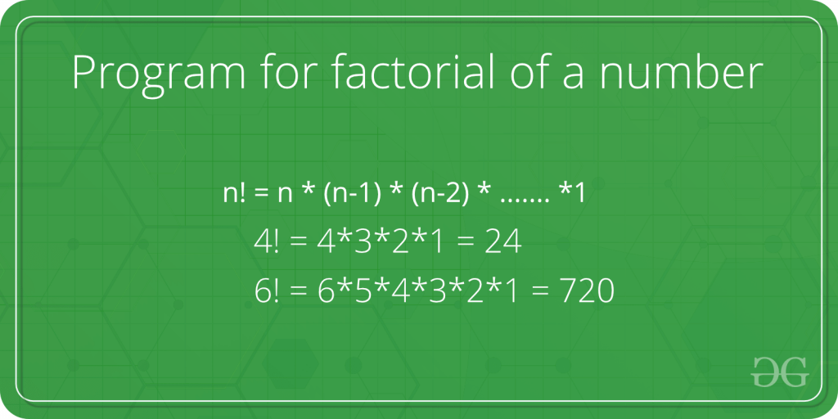C++

#include<iostream>

using namespace std;

int main()

{

int n, ans = 1;

cin >> n;

while(n>0)

{

ans *= n;

n--;

}

cout << ans;

return 0;

}

**INPUT :**

7

**OUTPUT :**

5040